Dear Parent/Guardian:
Children need healthy meals to learn. Elgin Math and Science Academy offers healthy meals every school day. Breakfast costs $2.35; lunch costs $4.90. Your children may qualify for free meals or for reduced price meals. Reduced price is $0.30 for breakfast and $0.40 for lunch. To apply for free or reduced-price meals, use the Household Eligibility Application, which is enclosed. We cannot approve an application that is not complete, so be sure to fill out all required information. Return the completed application to the school office.
Your child(ren) may qualify for free or reduced-price meals if your household income falls at or below the limits on this chart.
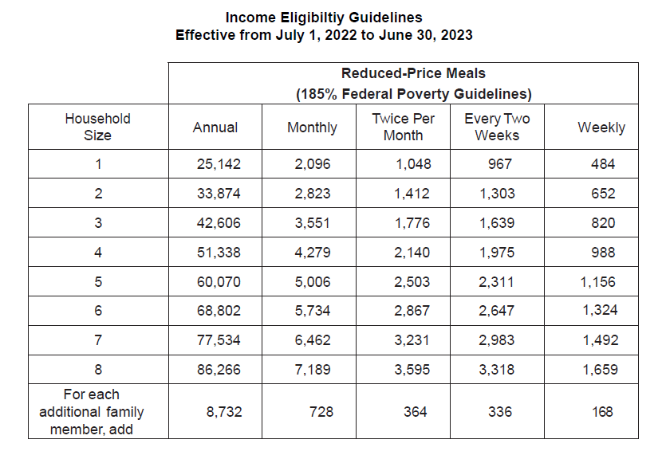
- Do I need to fill out an application for each child? No. Complete the application to apply for free or reduced-price meals. Use one Household Eligibility Application for all students in your household per district. We cannot approve an application that is not complete, so be sure to fill out all required information. Return the completed application to the school.
- Who can get free meals? All children in households receiving benefits from Supplemental Nutrition Assistance Program (SNAP), Temporary Assistance for Needy Families (TANF) and/or are foster children that are under the legal responsibility of a foster care agency or court are eligible for free meals regardless of your income. Also, your children can get free meals if your household’s gross income is within the free limits on the Federal Income Eligibility Guidelines. Children who meet the definition of homeless, runaway, or migrant also qualify for free meals. If you haven’t been told your children will get free meals, please contact your school to see if your child(ren) qualifies.
- WHO CAN GET REDUCED PRICE MEALS? Your children can get low-cost meals if your household income is within the reduced-price limits on the Federal Eligibility Income Chart, shown above.
- A MEMBER OF MY HOUSEHOLD RECEIVED SNAP OR TANF BENEFITS. THE SCHOOL SENT A LETTER STATING THAT MY CHILD IS AUTOMATICALLY APPROVED FOR FREE MEALS BASED ON DIRECT CERTIFICATION. DO I NEED TO DO ANYTHING MORE TO ENSURE THAT MY CHILD RECIEVES FREE MEALS? No. You do not need to do anything more to receive free meals for your child. If you have students not listed on the letter, contact the school immediately. If you do not wish to receive the free meals, you should follow the steps outlined in the letter from the school to notify school personnel immediately.
- HOW DO I KNOW IF MY CHILDREN QUALIFY AS HOMELESS, MIGRANT, OR RUNAWAY? Do the members of your household lack a permanent address? Are you staying together in a shelter, hotel, or other temporary housing arrangement? Does your family relocate on a seasonal basis? Are any children living with you who have chosen to leave their prior family or household? If you believe children in your household meet these descriptions and haven’t been told your children will get free meals, please contact your school.
- MY CHILD’S APPLICATION WAS APPROVED LAST YEAR. DO I NEED TO FILL OUT ANOTHER ONE? Yes. Your child’s application is only good for that school year and for the first few days of this school year. You must send in a new application unless the school told you that your child is eligible for the new school year.
- I GET WIC. CAN MY CHILD(REN) GET FREE MEALS? Children in households participating in WIC may be eligible for free or reduced-price meals. Please fill out the enclosed application.
- Will the information I give be checked? Yes. We may also ask you to send written proof.
- If I don’t qualify now, may I apply later? Yes, you may apply at any time during the school year. For example, children with a parent or guardian who becomes unemployed may become eligible for free and reduced-price meals if the household income drops below the income limit.
- What if I disagree with the school’s decision about my application? You should talk to school officials. You also may ask for a hearing by calling or writing to the person listed above.
- May I apply if someone in my household is not a U.S. citizen? Yes. You or your child(ren) do not have to be U.S. citizens to qualify for free or reduced-price meals.
- Who should I include as members of my household? You must include all people living in your household, related or not (such as grandparents, other relatives, or friends) who share income and expenses. You must include yourself and all children living with you. If you live with other people who are economically independent (for example, people who you do not support, who do not share income with you or your children, and who pay a pro-rated share of expenses), do not include them.
- What if my income is not always the same? List the amount that you normally receive. For example, if you normally make $1000 each month, but you missed some work last month and only made $900, put down that you made $1000 per month. If you normally get overtime, include it, but do not include it if you only work overtime sometimes. If you have lost a job or had your hours or wages reduced, use your current income.
- WHAT IF SOME HOUSEHOLD MEMBERS HAVE NO INCOME TO REPORT? Household members may not receive some types of income we ask you to report on the application or may not receive income at all. Whenever this happens, please write a 0 in the field. However, if any income fields are left empty or blank, those will also be counted as zeroes. Please be careful when leaving income fields blank, as we will assume you meant to do so.
- WE ARE IN THE MILITARY. DO WE REPORT OUR INCOME DIFFERENTLY? Your basic pay and cash bonuses must be reported as income. If you get any cash value allowances for off-base housing, food, or clothing, it must also be included as income. However, if your housing is part of the Military Housing Privatization Initiative, do not include your housing allowance as income. Any additional combat pay resulting from deployment is also excluded from income.
- My family needs more help. Are there other programs we might apply for? To find out how to apply for SNAP, TANF or other assistance benefits, contact your local Department of Human Services office or call (800) 843-6154 (voice) or (800) 447-6404 (TTY).

Sincerely,
Elgin Math and Science Academy

