Request for Proposal

General Contractor Services – Adaptive Reuse of 1929 Historic Administration Building

RFP Release Date: November 9, 2022
Clarifying Questions due to EMSA/WKA: November 15, 2022 5pm

RFP Response Due Date: 3pm, November 18th.

Responses should be delivered to: dalexander@emsacharter.org; Fabiola@wkarch com; larry@wkarch.com; emily@wkarch.com.

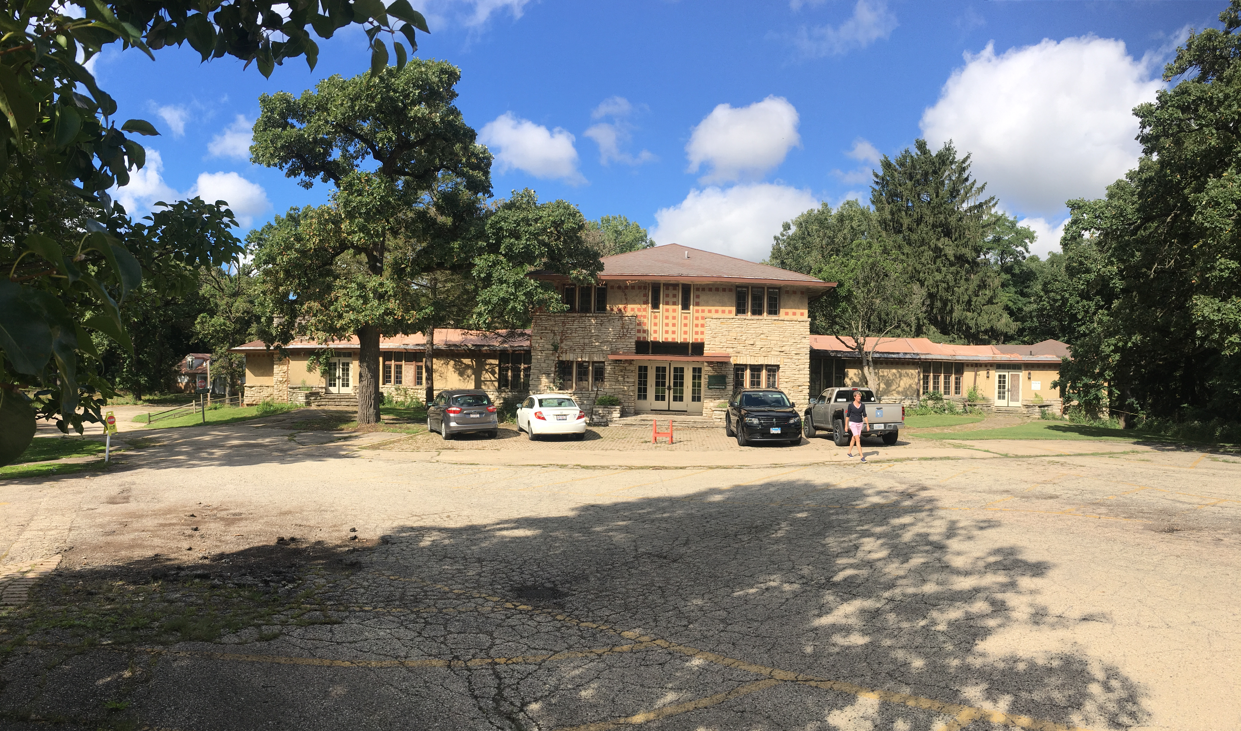

Elgin Math & Science Academy (EMSA) is a public charter school located at 1600 Dundee Avenue in Elgin, IL. EMSA is an operating K-7 School in SY2022-23, with more than 400 students and about sixty staff members. EMSA’s campus is a 19-acre site, containing seven buildings and a unique set of ecosystems, adjacent to a forested fen. The site contains many heritage oak trees. This nearly 100-year-old school campus, which is home to a rare wetland complex, is on a 53-acre site designated as an Illinois Nature Preserve. The campus contains a network of Prairie Style Buildings which the school is committed to preserving.

EMSA wishes to procure General Contractor construction administration services from a qualified Contractor, to work with its Architect/Engineering team led by Wheeler Kearns Architects, EMSA’s Chief Operating Officer Dan Alexander, and EMSA’s Board/Committee leadership to reconstruct EMSA’s Administration Building, and related campus improvements.

The Administration Building is a roughly 10,800 square feet, three story structure built in 1927 and designed by noted architect, John Van Bergen. The Building is intended to serve as a four-classroom school building once renovated. The actual construction renovation must begin in early January 2023 and be completed by end of July, 2023.

Proposal Requirements
The response, due on November 18, 2022 by 3pm, should include the following:

Firm Information
Provide a brief statement of firm qualifications and interest.
Contractor must have the experience and capacity to provide construction and close-out services in a timely and cost-efficient manner.
Identify Self-Performed Work capability.

Relevant Experience
Provide information on relevant experience in similar educational or institutional projects
Describe projects of similar scope, your firm’s history, the organizational structure of the firm, the location of offices and where the work will take place. Describe your firm’s knowledge and experience in working with local and state agencies having jurisdiction over the project.
Provide three client references that may be contacted.

Fee Approach
Provide a proposed fee on hard construction costs for the improvement work plus General Conditions and insurance for the project that would be used to establish the GMP at 75% Construction Documents. Please provide a fully detailed General Conditions budget so that EMSA may do evaluative comparisons fairly, between respondents.
Provide proposed fee for Change Orders including any subcontractor markups, for additional work and reductions in scope.
EMSA has not established a minimum goal for Minority-Owned and Woman-Owned Business Enterprises but would like to pursue 26% MBE and 6% WBE participation.

Key Personnel and Team Organization
Provide a list of key personnel involved in this project along with their title, resumes, and an organizational chart.
Provide an acknowledgment that these key individuals will be exclusively assigned to this project should the firm be awarded the project.

Schedule
Provide a proposed schedule for this project anticipating that the Administration Building will be granted a Certificate of Occupancy, and occupied as of July 31, 2023.

Logistics
Provide a proposed logistics plan that will enable students to attend school and/or summer programs in person on campus for the duration of construction.

Insurance
Provide a copy of your Certificate of Insurance identifying limits of coverage.

Contractor Exclusions, Qualifications and Exceptions
Provide a list of exclusions, qualifications, and exceptions, if any, for review.

Other
If EMSA awards a GMP Construction Contract based on 75% Construction Documents, provide a proposed contingency percentage based on the hard construction costs. Please state how any remaining contingency will be dispersed at closeout. If proposing sharing the remaining contingency, please state the proposed percentage of savings returned to the Owner and the percentage of contingency to be dispersed to the General Contractor.

A modified AIA form of contract between Owner and Contractor, has been included as an Exhibit to this Request for Proposal. Respondents are asked to confirm they would be willing to negotiate a contract using such contact language; if changes would be proposed in the language, please enumerate such changes.

Legal Disputes
List any litigation, arbitration, or mediation within the last five years including but not limited to disputes arising from any construction work for any public or private project. Explain the nature of each matter, whether it is still pending, resolved and the final result.

Site Inspection & In-Progress Set of Drawings
EMSA will host a site inspection visit by interested contractors on Monday November 14, 2022 at 1pm. Wheeler Kearns Architects will be onsite to answer questions. All questions will be recorded and answered in writing, with a record sent to all GCs who have responded with intent to bid, to Dan Alexander, Chief Operating Officer of EMSA at dalexander@emsacharter.org.

A set of in-progress construction documents have been included with this RFP. It is emphasized that these are in-progress documents only, and will not be fully representative of final construction documents.

20221107_Pre-Con Pricing_Addendum 1 (Ctrl+Click to follow link)

Interested contractors should state, in their response to this RFP, their willingness to enter into a contract for construction services, substantially similar to the documents linked below.
A102-2017 - EMSA Admin Bldg 11.2022.DOC - Google Docs (Ctrl+Click to follow link)
A201-2017 - EMSA Admin Bldg 11.2022.DOC - Google Docs (Ctrl+Click to follow link)

